Comments to UI Responsive layout–

New Claim Registration

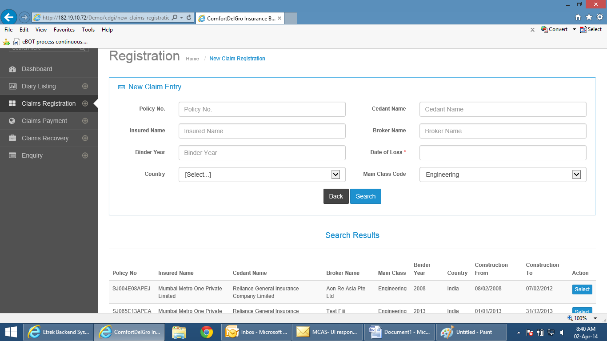

New Field below Policy No.– Endorsement No.

Main Class – default to Motor

Country – default to Singapore

Binder Year – change to Policy Year

Cedant Name – field not required to be captured

Column Display –

1. Policy No.
2. Sub-Class
3. Claim No.
4. Vehicle No.
5. Insured Name
6. Driver Name
7. TP Claimant
8. Date of Loss
9. Loss Type
10. Nature of Loss
11. Currency
12. Current Reserve
13. Paid Todate
14. Claim Status
15. IO = Investigating Officer
16. CO = Claims Officer
17. Action

If the tabs are too many, you may want to look into a drop-down or separate display to merge – Currency, Current Reserve, Paid Todate – into a single column “Reserves”. The column will display the Reserve amount and user click on it, system will display the additional info.

Claims Payment

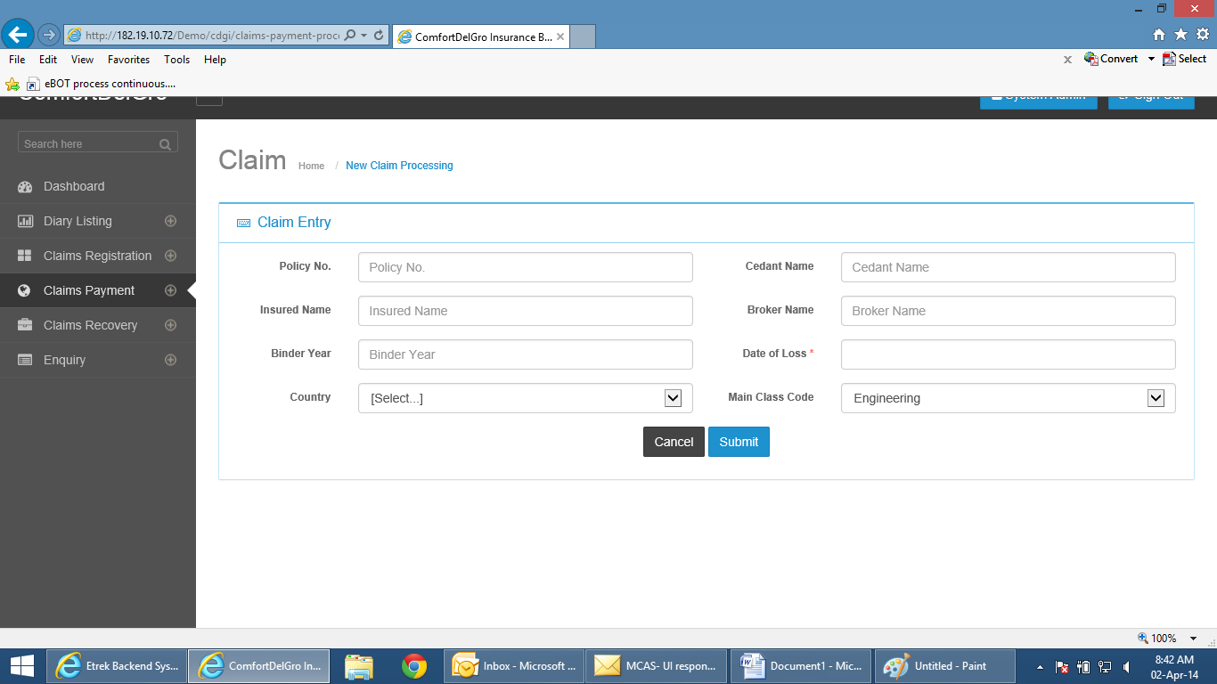

Screen fields follow Claims Registration

Change to Claims Payment Processing

Column Headers –

1. Policy No.
2. Sub-Class
3. Claim No.
4. Vehicle No.
5. Insured Name
6. Driver Name
7. TP Claimant
8. Date of Loss
9. Loss Type
10. Nature of Loss
11. Currency
12. Current Reserve
13. Paid Todate
14. Claim Status
15. IO = Investigating Officer
16. CO = Claims Officer
17. Action